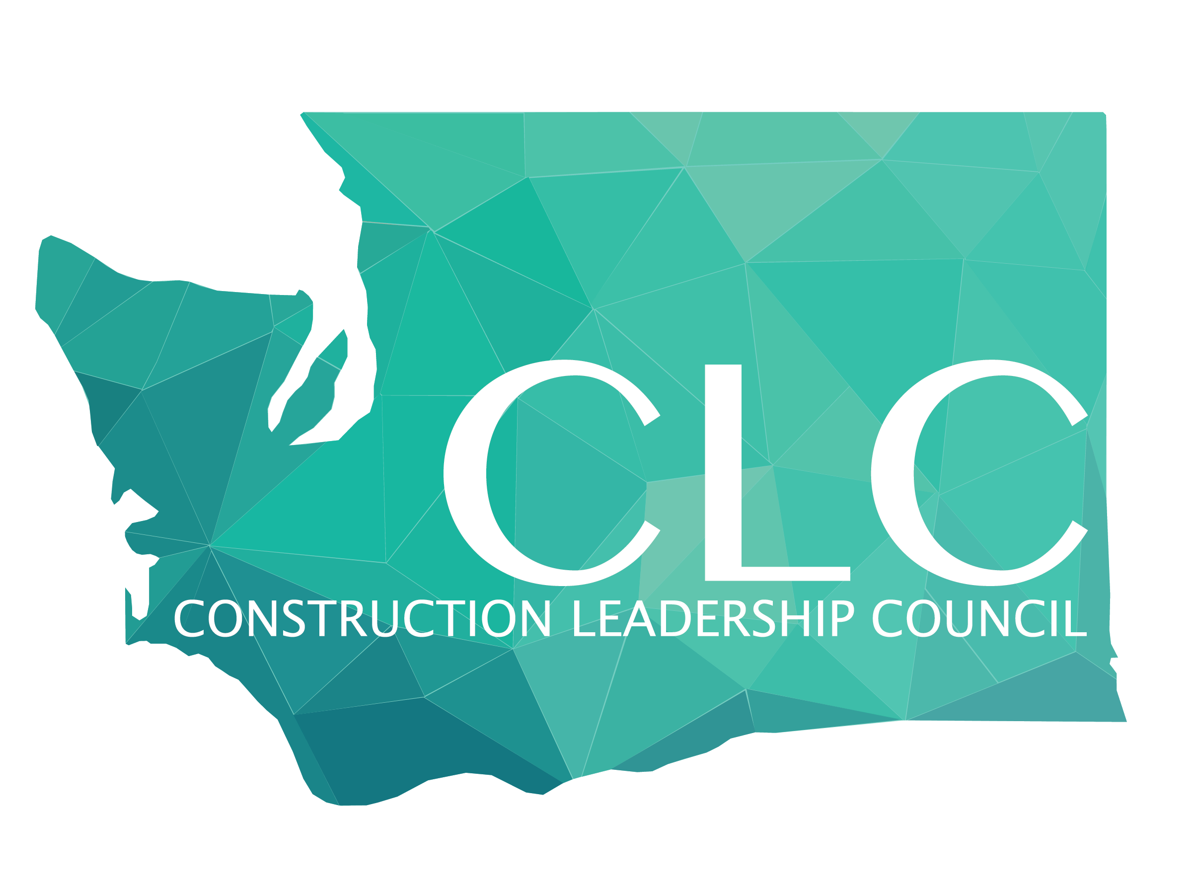
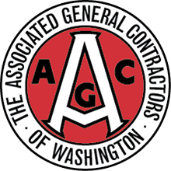

2020 AGC of Washington CLC Steering Committee Application
CLC provides professional development opportunities and enhances the leadership skills of early and mid-career construction professionals. It also functions as a forum in which members can network, socialize, and exchange ideas on the issues and challenges they face. CLC prides itself on the diversity of its membership, and welcomes all interested AGC members and associate members to attend its events without need for formal appointment.

Mission Statement:
AGC’s Construction Leadership Council (CLC) develops the next generation of construction leaders through education, philanthropy and social efforts to ensure the future success of our industry.

Make connections: Strengthen your network with AGC of Washington members
Give back: Collaborate with your peers to serve the local community
Educate yourself: Become an industry leader through professional-development

CLC is managed by a steering committee of 14 members, advised by AGC of Washington’s board of trustees. CLC steering committee members serve a two-year term with the option to apply for a second term of one year. The out-going CLC steering committee Chair serves a third year in an advisory role.

CLC Steering Committee Minimum Requirements:

CLC steering committee applicants must be able to (a) serve for a two-year term; (b) attend monthly planning meetings; (c) attend CLC events; and (d) participate in an CLC subcommittee (e.g., education, philanthropy, and social.). Participation in an AGC of Washington committee, division, group or non-CLC events is strongly encouraged.

CLC Steering Committee Application Evaluation Process:

Applicants must complete an application (pp. 2 & 3 below) and a commitment form (p. 4 below) signed by your employer. Please submit a letter of recommendation that should references the evaluation factors listed below. Completed applications and all supporting documents must be emailed to Andrew Ledbetter at aledbetter@agcwa.com by close-of-business on October 31, 2019.

Evaluation factors include completeness of application, potential for active and in-person participation, reliability for two-year commitment, diverse steering committee make-up (i.e. industry segments, services, etc.), and construction industry involvement. New steering committee members will be notified in December and begin service in January of the next year.

Space is limited, and several qualified applicants may end up competing for the same spot. Applicants not appointed to the CLC steering committee are strongly encouraged to continue their active industry involvement. We owe the CLC’s success to people like you, so stay involved. Good luck!

2020 AGC of Washington CLC Steering Committee Application

Thanks for your interest in the CLC Steering Committee. Please provide the following information:

Part One

Full Name:
Title & Company Name:
Company Address:
Phone: E-mail:
Type of work company performs?
Number of years with company?
Number of years in the construction industry?
AGC and/or CLC events you attended in the last two years?

Did you participate in an AGC Student Chapter in college?
Did you receive a scholarship from the AGC of America, Education Foundation?
Did you receive a scholarship from the AGC of Washington, Education Foundation?

2020 CLC Steering Committee Application

Part Two

Why do you want to join the AGC of Washington CLC Steering Committee?

______________________________________________________________________________

______________________________________________________________________________

What do you think you could bring to the table being part of the CLC Steering Committee? (i.e. personal characteristics, event ideas, membership involvement ideas, etc.)”
______________________________________________________________________________

______________________________________________________________________________

Please list any involvement you have had with the AGC of Washington and why, e.g., attended a conference, were encouraged to participate by your employer, CLC events, etc.

______________________________________________________________________________

______________________________________________________________________________

Please list any other miscellaneous information you would like the CLC Steering Committee members to consider about your application, including any volunteer or community activities or associations that you want the committee to be aware of.

______________________________________________________________________________

______________________________________________________________________________

Completed application forms, including employer commitment form and any recommendation letters, must be submitted before close of business Oct. 31, 2019 to:

CLC Steering Committee 2020
Andrew Ledbetter: aledbetter@agcwa.com

2020 CLC Steering Committee
Employer Commitment Form

By signing this form, I acknowledge that I have reviewed the AGC of Washington Guidelines and the application. I also am aware of the time commitment the nominee will need to make over the next two years (January 2020-December 2021) if his/her nomination is approved, and I and my firm/company fully support that commitment.

Name of Steering Committee applicant:

Company name:

Name of supervisor:

Title of supervisor:

Signature of supervisor:

